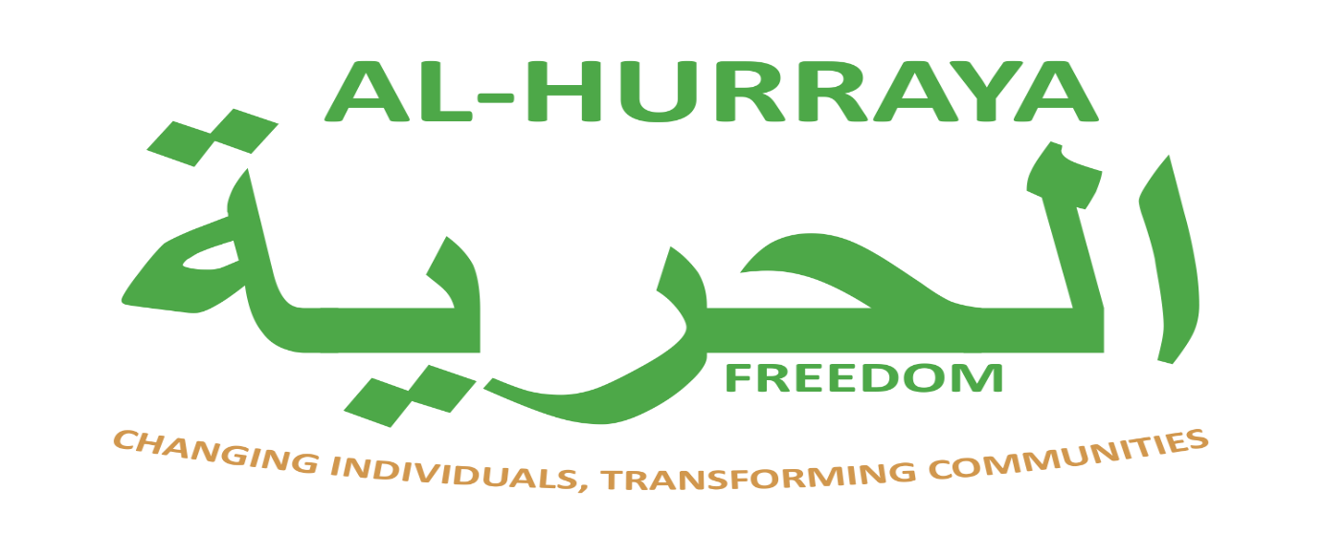

Privacy Policy

1. Introduction
Al-Hurraya is committed to protecting your personal data and respecting your privacy. This Privacy Policy explains how we collect, use, store, and protect your information when you access our services.
We comply with the UK GDPR and the Data Protection Act 2018.

2. About Us
Al-Hurraya is a lived experience recovery organisation supporting individuals affected by addiction through recovery-focused services, including the 12-step programme. Our work is informed by the lived experience of our founder and recovery lead, Asad Fazil, and our wider team.

3. Information We Collect
We may collect and process the following types of personal data:
- Personal details (name, address, phone number, email)
- Date of birth and basic identification information
- Health and wellbeing information relevant to recovery support
- Referral information from partner organisations
- Records of engagement with our services (sessions, workshops, support notes)
- Feedback, complaints, or survey responses

4. How We Use Your Information
We use your personal data to:
- Provide recovery and support services
- Assess your needs and tailor support appropriately
- Manage referrals and service access
- Communicate about appointments, sessions, and updates
- Monitor and improve our services
- Meet legal, safeguarding, and funding obligations

5. Lawful Basis for Processing
We process your data under the following lawful bases:
- Consent – where you have given clear permission
- Contract – to deliver agreed services
- Legal obligation – including safeguarding requirements
- Legitimate interests – to provide effective support services
For sensitive personal data (such as health information), we process it under additional conditions for the provision of health or social care.

6. Sharing Your Information
We will only share your data when necessary and appropriate:
- With your consent
- With partner organisations involved in your care or support
- Where required by law (e.g. safeguarding concerns)
- With funders or auditors (in anonymised or limited form where possible)
We do not sell or trade personal data.

7. Data Security
We take appropriate technical and organisational measures to protect your data, including:
- Secure password-protected systems
- Restricted access to authorised staff only
- Staff training on confidentiality and data protection
- Secure storage of paper records in locked facilities

8. Data Retention
We retain personal data only for as long as necessary to provide services and meet legal, safeguarding, and funding requirements.
Retention periods are defined in our Retention & Disposal Policy.

9. Your Rights
Under the UK GDPR, you have the right to:
- Access your personal data
- Request correction of inaccurate data
- Request deletion of your data (where applicable)
- Object to or restrict processing
- Withdraw consent at any time

10. How We Protect Vulnerable Information
As a recovery organisation, we may process sensitive health-related information. This is handled with strict confidentiality and only shared when necessary for safety, safeguarding, or care coordination.

